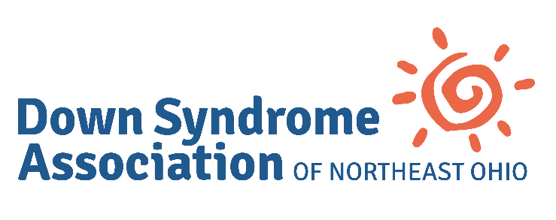
The Richard D. Greene Adoption Grant
Overview
RDG Adoption Grants provide financial assistance to families who have adopted a child of any age who has Down syndrome. The grant can be used to address the costs of adoption or to help improve the life of the child with Down syndrome. Grant amounts are up to $1000.00 each and are awarded based on the availability of funds, which may vary depending on donations and use.
About Richard D. Greene
The Richard D. Greene Adoption Grant was developed in memory of a man who was devoted to family and whose career was spent helping others. While in college, Rich worked as a camp counselor for children with special needs, where his passion for individuals with Down syndrome was kindled. In an unexpected way, these experiences were foreshadowing for real life and shortly thereafter, Rich’s second child was born with Down syndrome. Just two years later, the Greenes became aware of a baby who had been left at the hospital after her biological parents discovered she had Down syndrome. They adopted her and added her to the three children already in their family. Rich did not consider himself “special” for adding another child with Down syndrome to his brood. Instead, he considered himself lucky. Rich’s spirit and personality were larger than life. He was an avid Cleveland sports fan, funny and sarcastic, lover of dogs and all things chocolate. He was a giver of hugs and source of laughter. He was the one you could always turn to because you knew he would be there. He was selfless, creative, loving, and kind. Most of all, he was family. Rich passed away in 2019 from a neurodegenerative disease, leaving his wife, 4 children, 2 step-children, 5 grandchildren and his dog, Bailey.
Eligibility
- Grants are not based on the financial status of the family.
- Grants will be awarded once per calendar year per child adopted.
- Adoption grants are nonrenewable.
- To qualify, applicants must be a resident of Ashland, Ashtabula, Cuyahoga, Erie, Geauga, Holmes, Huron, Lake, Lorain, Medina, Portage, Richland, Stark, Summit, Tuscarawas or Wayne counties. Applicants who live elsewhere but have adopted a child from these counties will also be considered.
- Adoption must have been finalized by the courts within the last two years.

Application Process
Grant applications are being accepted through April 30, 2022. Please complete the attached grant application. Feel free to include an explanation of any unusual circumstances regarding your need. Applications will not be considered without attachment of a court document indicating the finalization of the adoption. Applications should be submitted by email to grantscommitte@dsaneo.org. Once submitted, the application will be reviewed and a determination letter will be sent to the applicant, regardless of outcome. If you need any assistance, call DSANEO at 216-447-8763 or email grantscommittee@dsaneo.org.

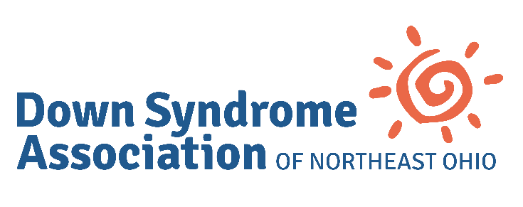
The Richard D. Greene Adoption Grant Application
Individual with Down syndrome:
Date of Birth:
Parents:
Street Address:
City: County:
State: Zip Code:
Email Address:
Phone:
Dependent children in the home (Names/Ages):
How did you hear about the Down Syndrome Association of Northeast Ohio?
Why did you choose to adopt?

Are you interested in participating in activities through the Down Syndrome Association of Northeast Ohio?
Check all that apply:
□ Parent groups
□ Grandparents group
□ Facebook groups
□ Buddy Walk
□ Sunburst Gala
□ Holiday party

Special circumstances to consider:
Send completed application and documentation to grantscommittee@dsaneo.org by April 30, 2022.

